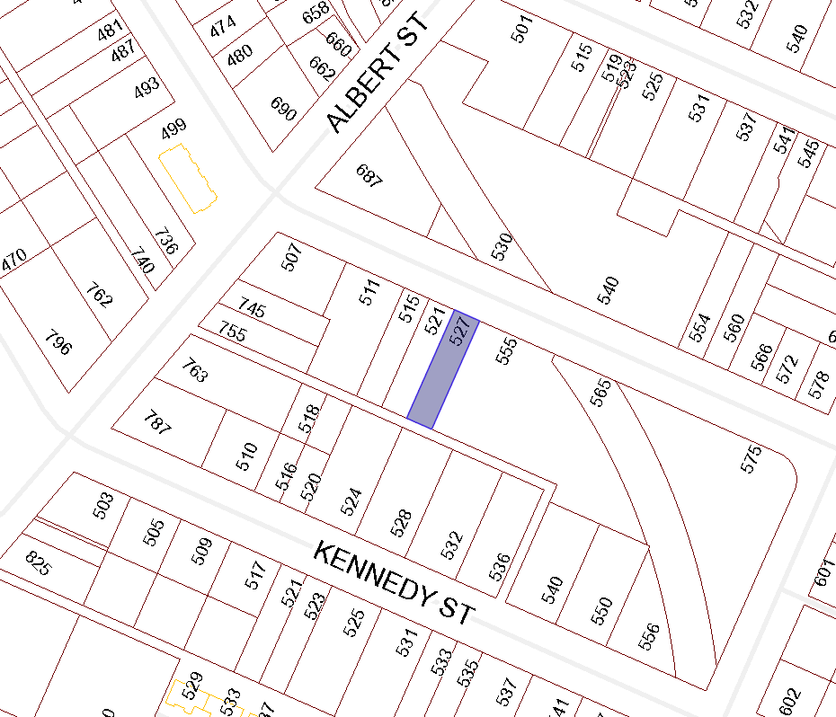

BOARD OF VARIANCE APPLICATION BOV00664

LOCATION MAP

CIVIC: 527 MILTON STREET

LEGAL: THE WESTERLY ½ OF SECTION A, LOT 8, BLOCK G, SECTION 1, NANAIMO DISTRICT, PLAN 584

